**CENWP-OD-B31 July 2024**

**MEMORANDUM FOR THE RECORD**

**SUBJECT: 24BON038 MFR Salmonid Mortality**

On the morning of 31 July, Project Biologists discovered one juvenile salmonid mortality on the walkway leading to the WA Shore Exit. The fish was scanned for PIT tags and returned to the river.

1. Species – Chinook
2. Origin – Unknown
3. Length – 29.2 cm
4. Marks and tags – Adipose Clipped
5. Marks and Injuries found on carcass – Avian predation marks
6. Cause and Time of Death – Avian Predation, Unknown time
7. Future and Preventative Measures – None

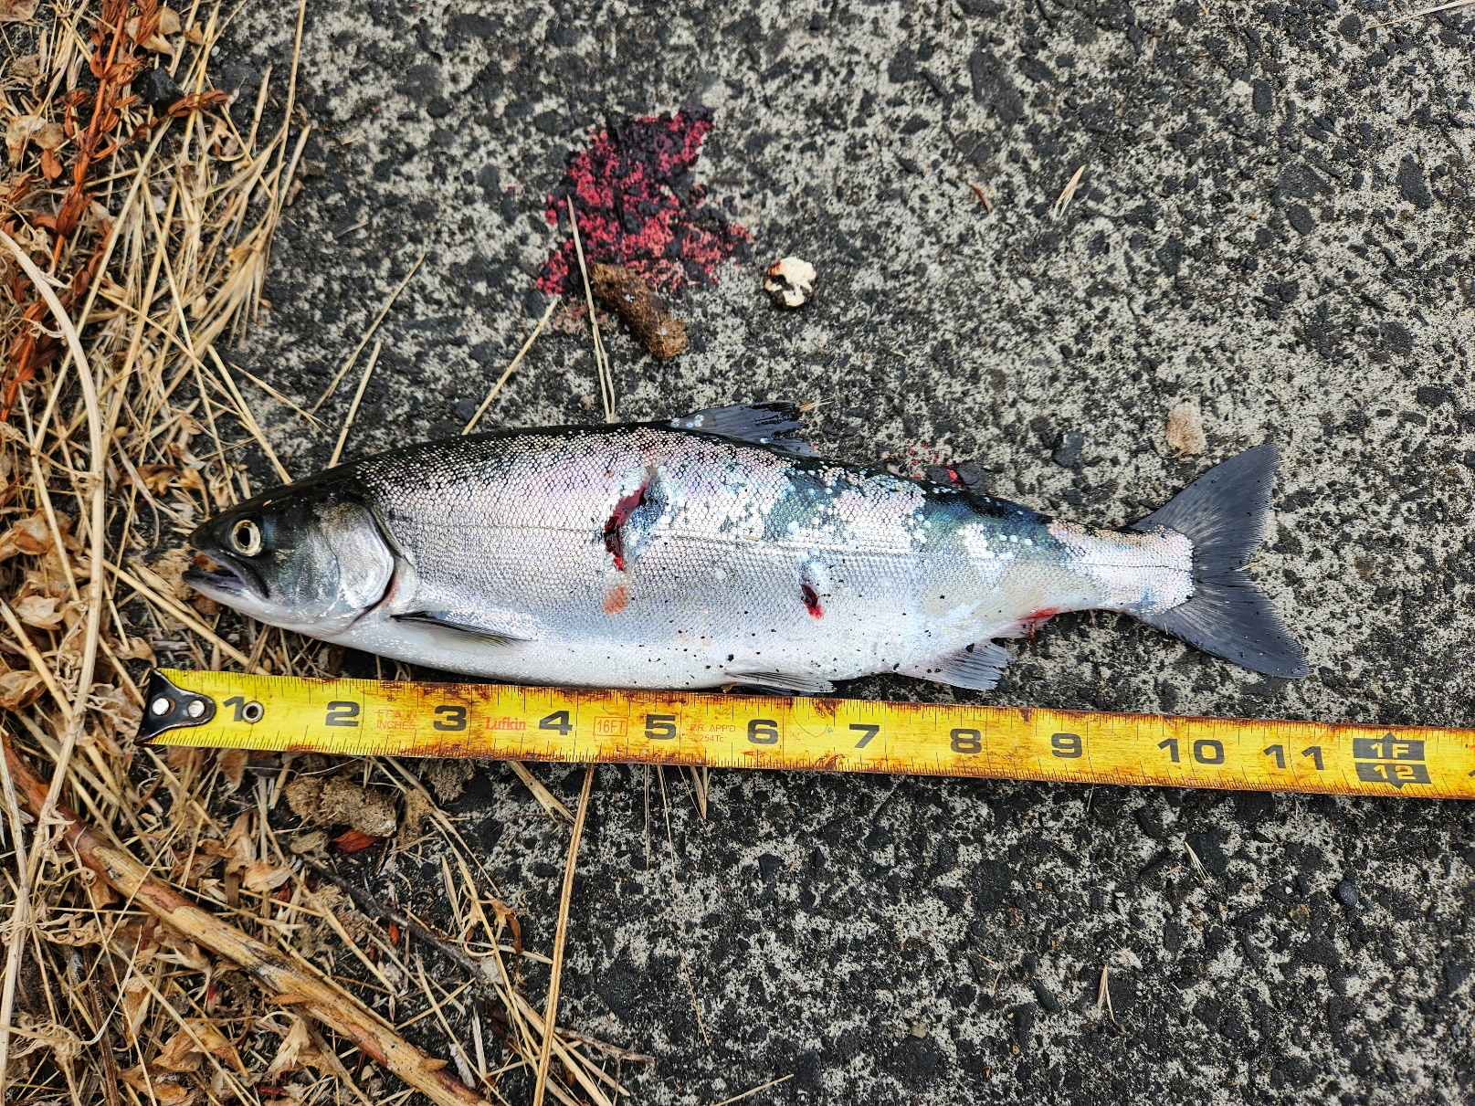

Sincerely,

Project Fisheries